Lab Assignment-2

-- 1.

CREATE TABLE emp (empno number(10),ename varchar2(20), job varchar2(20), sal number(10), deptno number(10))

;

-- 2.

INSERT INTO emp (empno, ename, job, sal, deptno)

VALUES (1,'Harry','Salesperson',2000, 10)

;

INSERT INTO emp (empno, ename, job, sal, deptno)

VALUES (2,'Soni','Clerk',3000, 20)

;

INSERT INTO emp (empno, ename, job, sal, deptno)

VALUES (3,'Tony','Salesperson',2500, 30)

;

INSERT INTO emp (empno, ename, job, sal, deptno)

VALUES (4,'Chloe','Manager',4500, 20)

;

INSERT INTO emp (empno, ename, job, sal, deptno)

VALUES (5,'Stoc','Clerk',3000, 10)

;

INSERT INTO emp (empno, ename, job, sal, deptno)

VALUES (1,'Aanya','Clerk',1000, 20)

;

UPDATE emp SET empno = 6 WHERE ename = 'Aanya'

;

INSERT INTO emp (empno, ename, job, sal, deptno)

VALUES (7,'Grub','Clerk',1500, 10)

;

-- 3.

SELECT empno, ename FROM emp WHERE deptno = 10

;

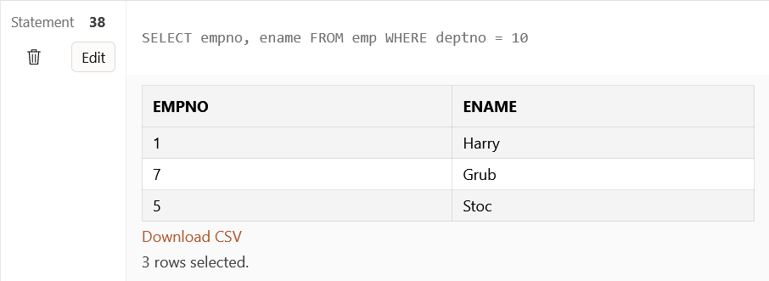

-- 4.

SELECT ename FROM emp WHERE job = 'Clerk' and sal > 2000

;

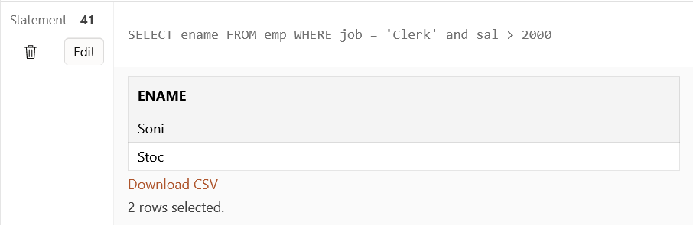

-- 5.

SELECT ename, sal FROM emp WHERE job = 'Clerk' or job = 'Salesperson'

;

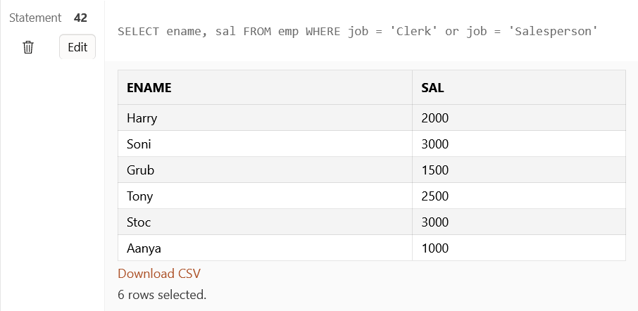

-- 6.

SELECT * FROM emp WHERE sal>2000 AND sal<3000

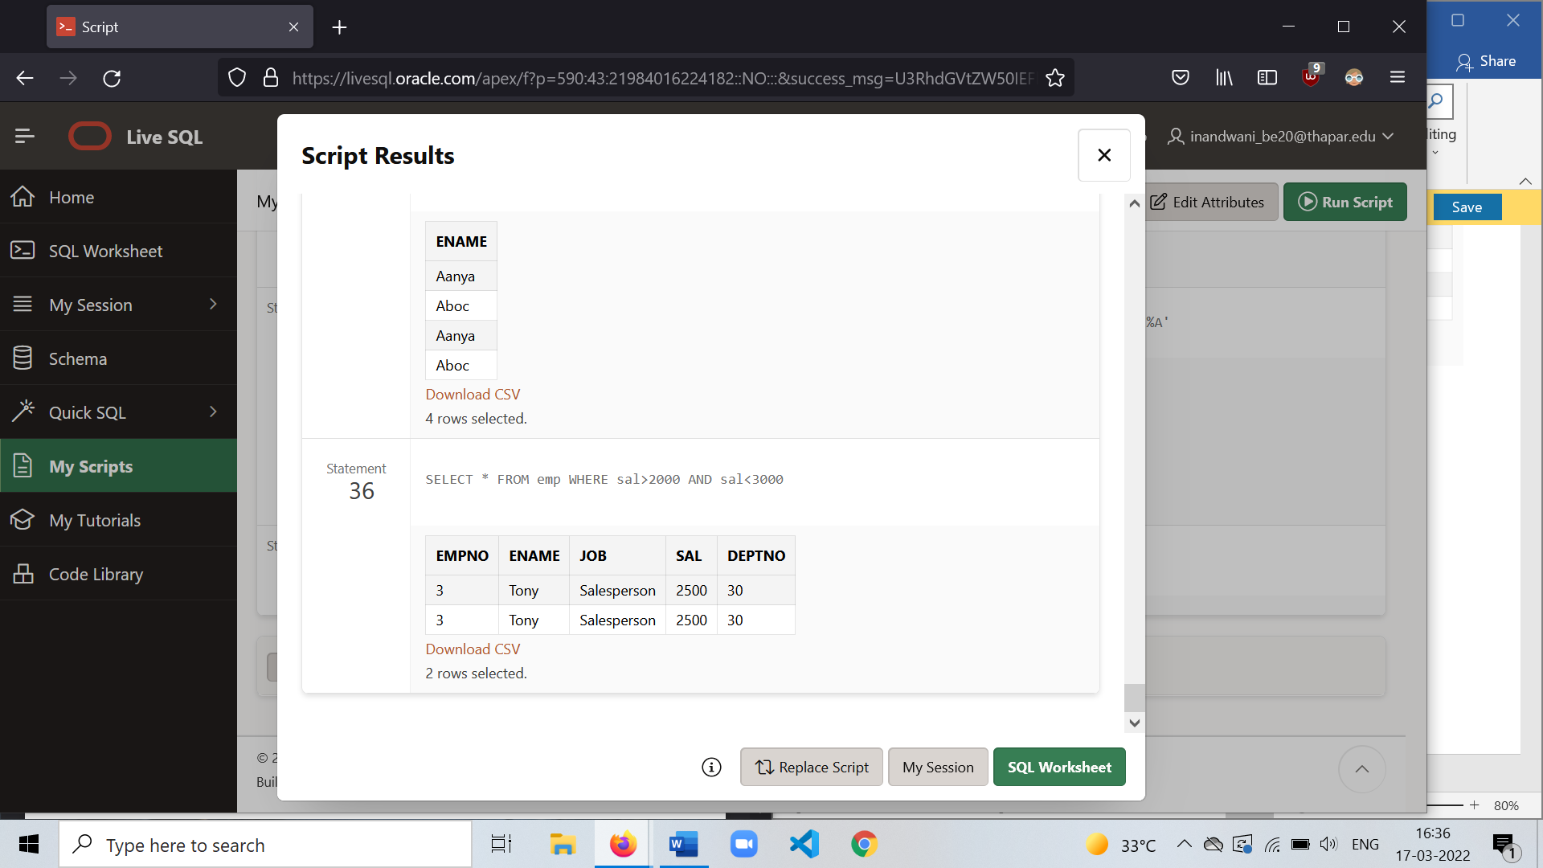

--7.

SELECT * FROM emp WHERE deptno = 10 or deptno = 20 or deptno = 30

;

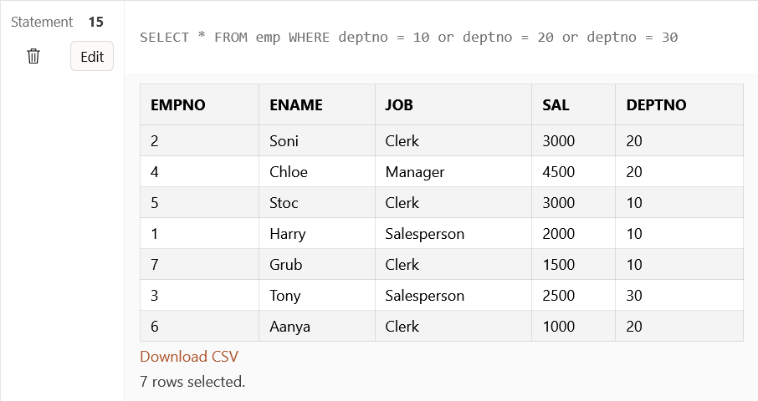

--8. Commission not given in the question- ambiguity

-- 9.

SELECT deptno, sal FROM emp WHERE deptno ASC and sal DESC

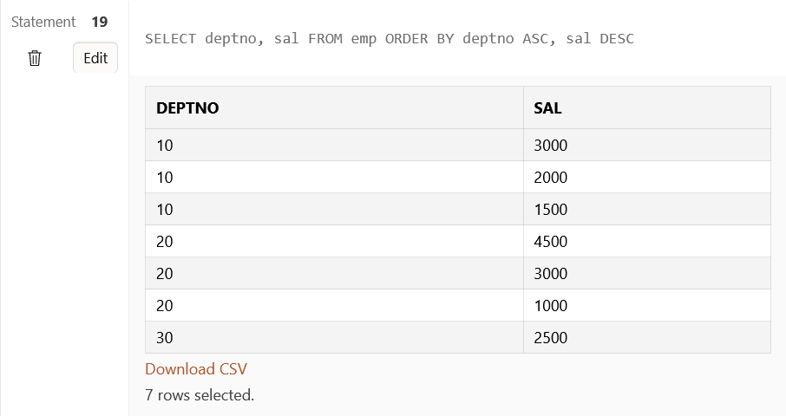

--10.

SELECT ename FROM emp WHERE ename LIKE 'C%'

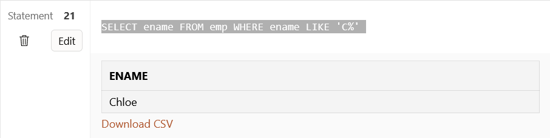

--11.

SELECT ename FROM emp WHERE ename LIKE '%c' or ename LIKE '%C'

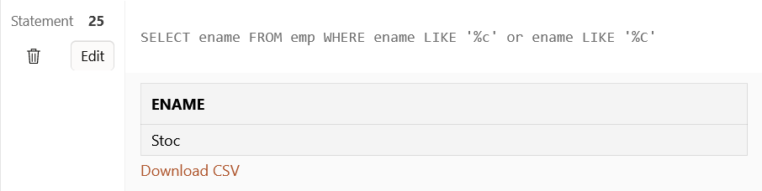

--12.

SELECT ename FROM emp WHERE ename LIKE '%AA%' or ename LIKE '%aa%' or ename LIKE '%Aa%'

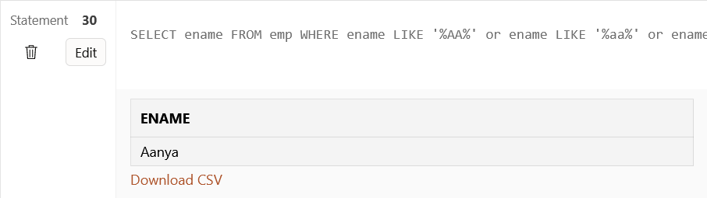

-- 13.

SELECT ename FROM emp WHERE ename LIKE '_B%' or ename LIKE '_b%'

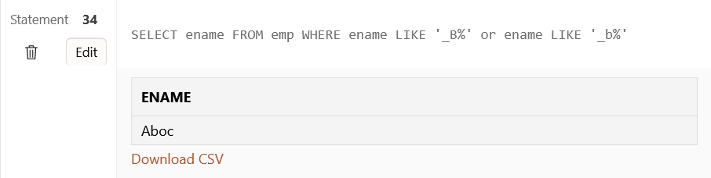

-14.

SELECT ename FROM emp WHERE ename LIKE 'A%' or ename LIKE 'a%'or ename LIKE '%a'or ename LIKE '%A'

